**Advance Excel Assignment 16**

1. What is a Macro? How is it useful in excel or in your daily work?

Ans. A macro is shorthand for a programming term: macroinstruction. In the most basic terms, a macro is a way to automate simple tasks. They can be used in a variety of ways, but most of us will learn to love them as helpful shortcuts in Microsoft Excel.

A macro is a set of instructions used to execute repetitive tasks. User can record a set of commands and then play them back with one or two keystrokes.

That means that user can save a lot of time when doing routine and repetitive tasks.

Excel is used in so many work processes. Say every week you export analytics data from your content management system (CMS) to create a report about your site. The only problem is, those data exports aren't always in an Excel-friendly format. They're messy and often include far more data than your report requires. This means you have to clean up empty rows, copy and paste data into the right place, and create your own charts to visualize data and make it print-friendly. All of these steps may take you hours to complete.

1. What is VBA? Write its full form and briefly explain why VBA is used in excel?

Ans. VBA is an abbreviation for Visual Basic for Application. VBA is a programming language that was developed by Microsoft Corp., and it is integrated into the major Microsoft Office applications, such as Word, Excel, and Access.

The VBA programming language allows users to access functions beyond what is available in the MS Office applications. Users can also use VBA to customize applications to meet the specific needs of their business, such as creating user-defined functions, automating computer processes, and accessing window APIs.

1. How do you record a macro? Write detailed steps to create a macro to automatically make the following table in bold and to create borders for it in excel.

hi 78

hello 69

ineuron 45

Ans. Record a Macro :

* In the Code group on the Developer tab, click Record Macro.
* Optionally, enter a name for the macro in the Macro name box, enter a shortcut key in the Shortcut key box, and a description in the Description box, and then click OK to start recording.

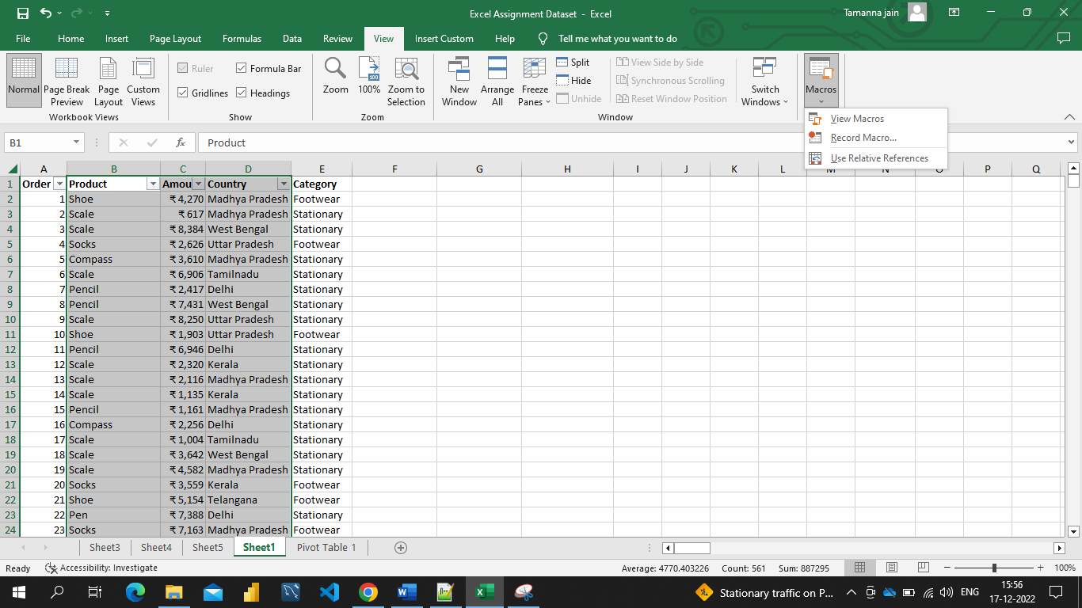

* Perform the actions you want to automate, such as entering boilerplate text or filling down a column of data.
* On the Developer tab, click Stop Recording.
* For the below data I’ve applied the above steps also given the macro name : Test, shortcut key : ctrl+t and description : testing

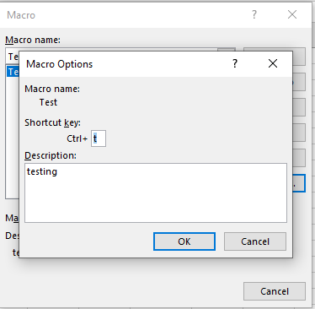

|  |
| --- |
| **hi 78** |
|  |
| **hello 69** |
|  |
| **ineuron 45** |

1. What do you mean when we say VBA Editor?

Ans. Visual Basic Editor is a separate application that is a part of Excel and opens whenever you open an Excel workbook. By default, it’s hidden and to access it, you need to activate it.

There are multiple ways you get the code in the VB Editor:

* When you [record a macro](https://trumpexcel.com/record-macro-vba/), it automatically creates a new module in the VB Editor and inserts the code in that module.
* You can manually type VB code in the VB editor.
* You can copy a code from some other workbook or from the internet and paste it in the VB Editor.

1. Briefly describe the interface of a VBA editor? What is properties window? And what is watch window? How do you display these windows?

Ans. The basic VBE window can be divided in the following 6 sections,

1. Menu Bar
2. Toolbar
3. Project Window / Project Explorer
4. Properties Window
5. Programming Window / Code Window / Module Window
6. Immediate Window

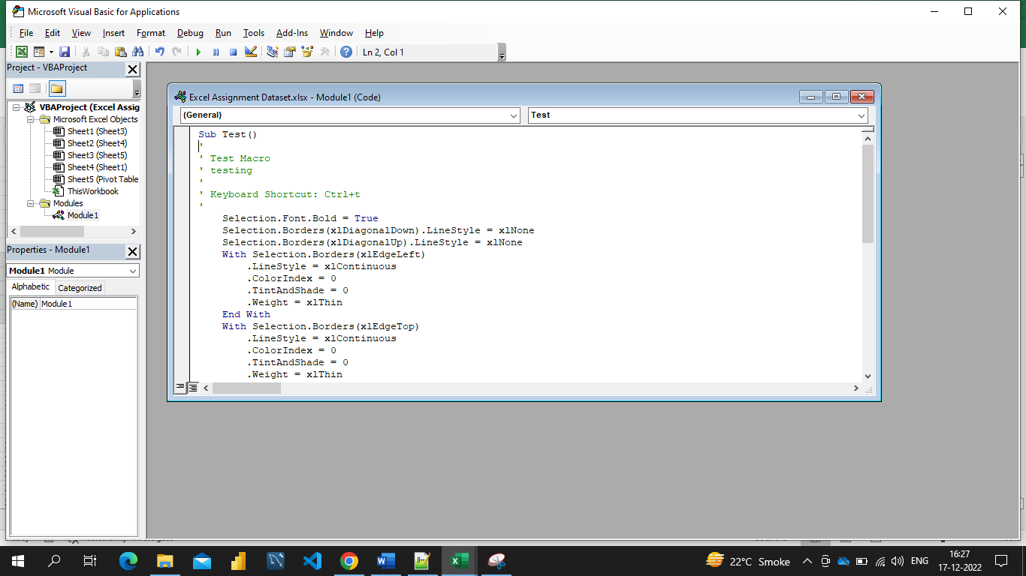

The Visual Basic Editor:

* Has several windows.
* Is highly customizable.

The Visual Basic Editor allows you to, for example:

* Hide or un-hide windows.
* Move or re-arrange windows.
* Dock windows.

Properties window: The Properties Window **displays the properties of the object that is currently selected**in the Project Explorer and allows you to edit those properties.Just as with the Project Window, you can hide or unhide the Properties Window.

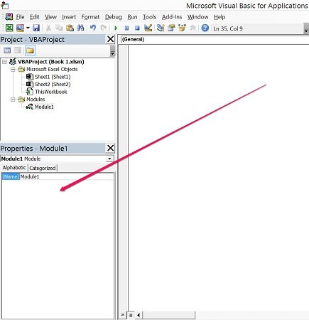

Watch Window: A watch expression is an expression that you define to be monitored in the Watch window. When your application enters break mode, the watch expressions you selected appear in the Watch window where you can observe their values.

To add a watch expression : On the Debug menu, choose Add Watch. The Add Watch dialog box is displayed.

If an expression is already selected in the Code window, it is automatically displayed in the Expression box. If no expression is displayed, enter the expression you want to evaluate.

1. What is an immediate Window and what is it used for?

Ans. Use the Immediate window to debug and evaluate expressions, execute statements, and print variable values. The Immediate window evaluates expressions by building and using the currently selected project.

To display the Immediate window, open a project for editing, and then choose Debug > Windows > Immediate or press Ctrl+Alt+I. You can also enter Debug. Immediate in the Command window.The Immediate window supports IntelliSense.

* Display the values of variables
* Design-time expression evaluation
* Enter commands
* Mark mode
* First-chance exception notifications